 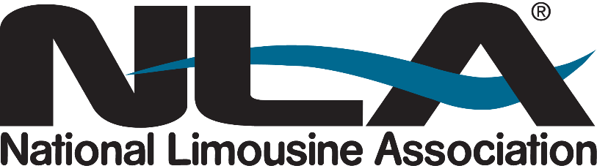

**NATIONAL LIMOUSINE ASSOCIATION ADVOCATES FOR INDUSTRY REFORMS ON CAPITOL HILL**

*Ground Transportation Industry Urges Congressional Action on Key Policy Priorities*

**MARLTON, N.J. – April 30, 2025 –**The [National Limousine Association (NLA)](https://www.limo.org/) – a trade organization dedicated to representing and furthering the national, state and local interests of the prearranged ground transportation industry – held its 25th annual advocacy event in Washington, D.C., on April 29. Eighty-one members representing 33 states engaged nearly 90 policymakers to advocate crucial legislative and regulatory reforms essential to the future of small business operators across the nation.

“Chauffeured ground transportation is a critical part of America's transportation system, for both business and leisure travel,” said NLA President Brett Barenholtz. “Without thoughtful policy support, operators will face unnecessary barriers to growth and sustainability. We urge Congress to protect the future of our industry and the millions of Americans it serves.”

Representing thousands of small business owners – with 69% operating between 1–10 vehicles and 96% operating fewer than 50 – the NLA is a vital voice for sedan, shuttle, limousine and motorcoach operators, as well as associated suppliers and manufacturers. The NLA urged Congress to take decisive action on several key issues that impact the competitiveness, sustainability and long-term success of the industry.

The NLA’s top priorities for 2025 include:

* **Restoring Bonus Depreciation:** Extend Section 168(k) to allow businesses to continue deducting the full expense of new vehicle purchases in the year of acquisition, critical for fleet modernization and cost control.
* **No Tax on Tips:** Support provisions that would eliminate federal taxes on employee tips, improving workforce retention and supporting frontline workers.
* **Enhancing Section 179 Deductions:** Strengthen small business investment incentives by increasing and expanding Section 179 expensing capabilities.
* **Preventing Harmful Congestion Taxes:** Pass the Economic Impact of Tolling Act to require comprehensive economic analyses before cities can impose congestion pricing schemes that harm businesses and communities.
* **Addressing the Insurance Crisis:** Establish a federal task force through the Surface Transportation Reauthorization Bill to study and develop solutions to address the rising costs of commercial auto insurance.
* **Ensuring Airport Access and Fairness:** Extend FAA grant assurances to ground transportation providers to ensure equitable access, fair treatment, and competitive fee structures at airports nationwide.

The NLA remains committed to working with lawmakers on both sides of the aisle to secure a fair and competitive operating environment for its members and to ensure the prearranged ground transportation sector continues to provide safe, efficient, and reliable service for communities across the country. Congressman Mike Lawler (R-New York) joined members while preparing for meetings for a productive roundtable discussion on key issues including congestion pricing, which he strongly opposes.

For more information about the NLA, visit [www.limo.org](http://www.limo.org).

###

**About the National Limousine Association**

Celebrating its 40th anniversary this year, the National Limousine Association is an organization responsible for and dedicated to representing the interests of the chauffeured ground transportation industry at the global, national, state and local level. It is the unified voice of this industry – linking transportation industry professionals from owners and operators to suppliers, manufacturers, regional and state limousine associations. With 1,300+ NLA members, the Association is committed to exceeding expectations with regards to professionalism, transportation efficiency and safe riding.

**Media Contact**

Jenna Koeble | Michelle Kelly

Evins Communications

[nla@evins.com](mailto:nla.media@evins.com)

(212) 688-8200